**Group A**

1. Which feature of OOP indicates code reusability?

Abstraction

Polymorphism

Encapsulation

* Inheritance

2. Which of the following is not an access modifier?

* Abstract

Public

Private

Protected

3. Encapsulation is a way of combining both data members and member functions, which operate on those data members, into a single unit. We call it a class in OOP generally. This feature have helped us modify the structures used in C language to be upgraded into class in JAVA and other languages. Show the process encapsulation in JAVA.

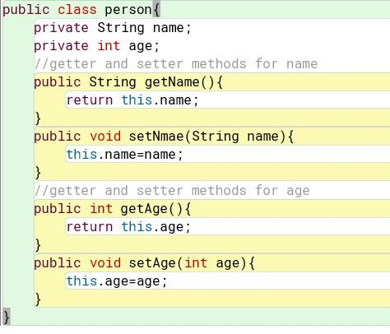

**Group B**

1. Create a class named 'Student' with String variable 'name' and integer variable 'roll_no'.  Assign the value of roll_no as '2' and that of name as "John" by creating an object of the class Student.

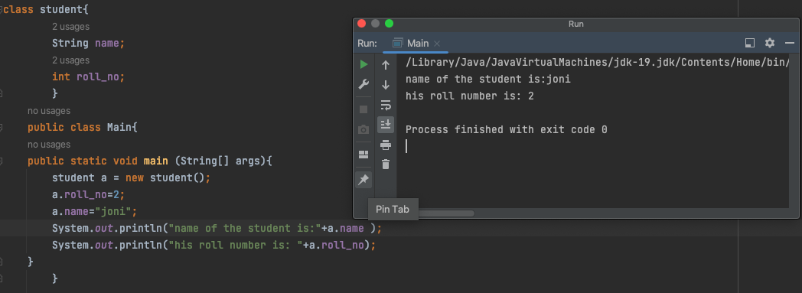

2. A rectangle has the length of 6 centimeters and width 4cm. Create a method each to print  the area and perimeter of the given rectangle.

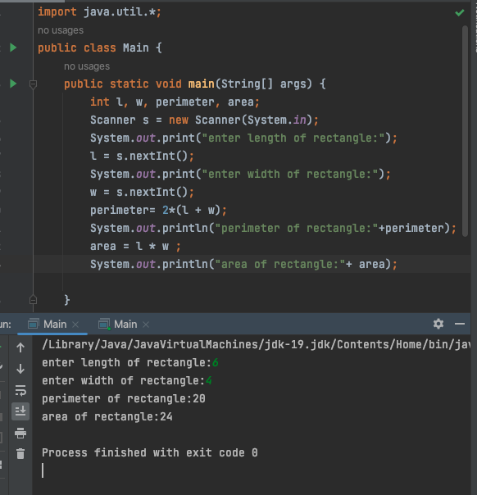

3. Write a program to print the simple interest by creating a class named “Savings” taking the values of its Principle, Time and Rate as parameters of a method named “Interest”.

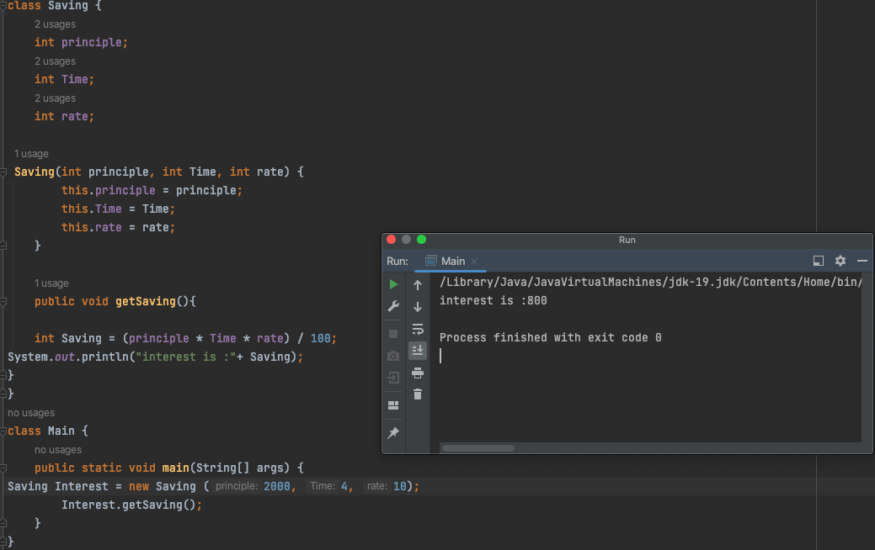

**Group C**

1. Write a program to find the sum of three numbers. Create a method findSum() of integer  return type to print the sum.

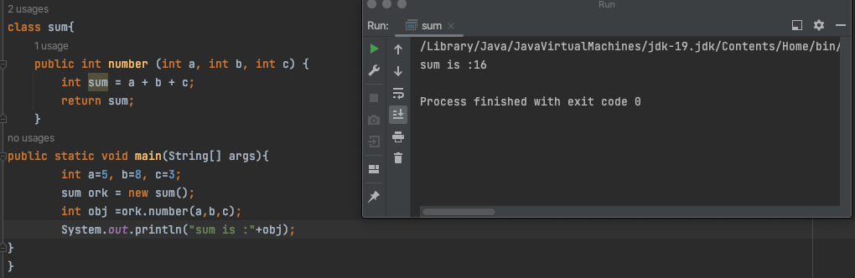

2. Write the program to find the average of three input numbers by using a method returning  a double value.

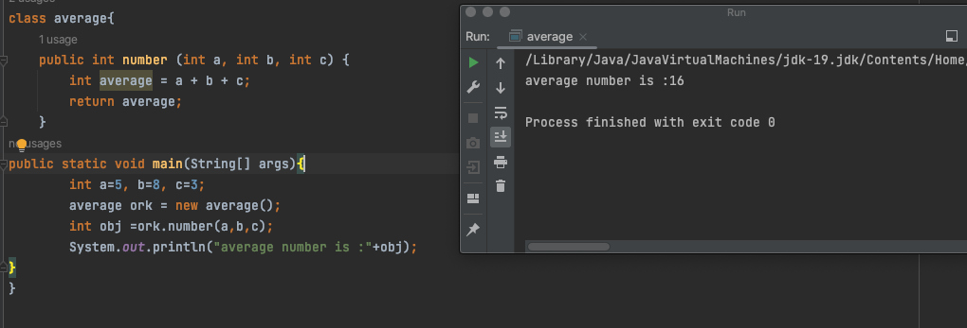

3. Create a class named 'Employee' having the following members:

Data members:

● Name

● Age

● Phone number

● Address

● Salary

It also has a method named 'printSalary' which prints the salary of the members. Now, assign name, age, phone number, address and salary to an employee by making an object of  both of these classes and print the same.

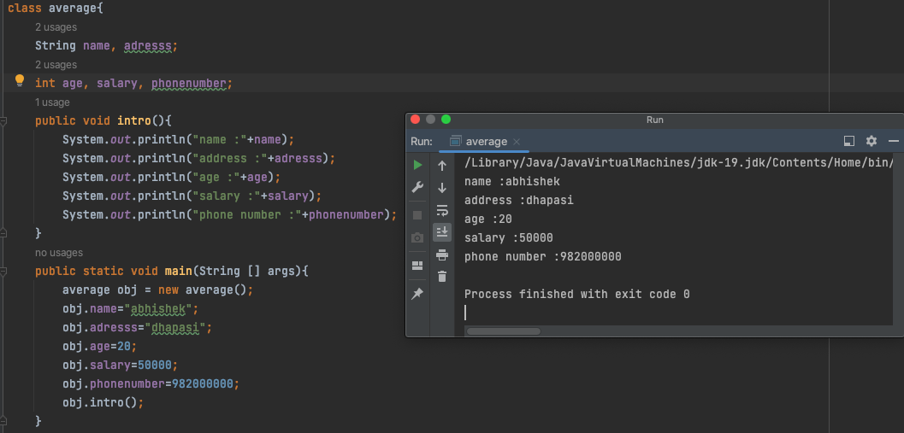

**Group D**

1. Create a simple calculator program using java OOP.

a. Take two non-zero inputs.

b. Create a method to print sum, difference, product and quotient.

c. Ask the user to choose between options (1-4) for sum, difference, product and divide operations.

d. Give the user choice of another operation.